SKI | SKATE | RUN | DIVE | SWIM | DANCE | SING | play TENNIS  BASKETBALL  FOOTBALL | RIDE A BIKE | CAN´T
[skiː] | [skeɪt] | [rʌn] | [daɪv] | [swɪm] | [dɑːns] | [sɪŋ] | [pleɪ ˈtenɪs]  [ˈbɑːskɪtˌbɔːl]  [ˈfʊtˌbɔːl] | [raɪd ə baɪk] | [ka:nt]
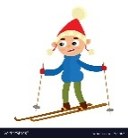 | 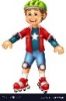 | 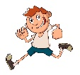 | 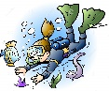 | 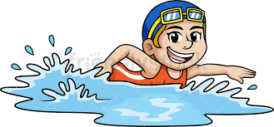 |  | 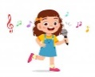 |  | 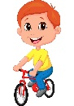
lyžovat | bruslit | běhat | potápět se | plavat | tančit | zpívat | hrát tenis, basketbal, fotbal | jezdit na kole | neumět
Unit 1 – SPORTS - SPORTY
