UNDER | BEHIND | IN | ON | PLANT | PICTURE | DRAWER | CUPBOARD | SOFA | CHAIR | TV | WHERE´S…?
[ˈʌndə] | [bɪˈhaɪnd] | [ɪn] | [ɒn] | [plɑːnt] | [ˈpɪktʃə] | [ˈdrɔːə] | [ˈkʌbəd] | [ˈsəʊfə] | [tʃeə] | [ˌtiːˈviː] | [weəz]
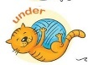 |  |  |  | 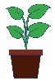 | 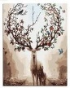 | 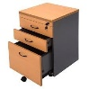 | 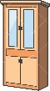 | 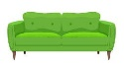 | 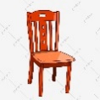 | 
pod | za | v | na | rostlina | obrázek | zásuvka | příborník | pohovka | židle | televize | Kde je…?
Unit 2 – WHAT´S IN THE HOUSE?(2) – CO JE V DOMĚ?

